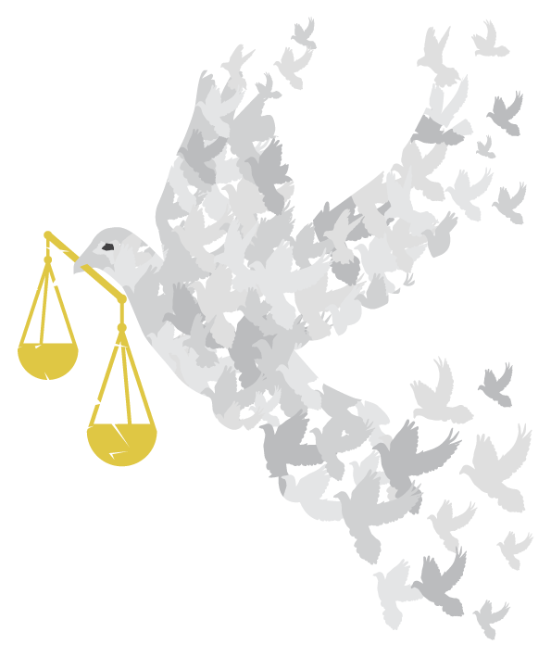

to build a more equal and peaceful world

QUOTATIONS
QUOTATIONS

Introduction:
We have collected together here a selection of quotations about the following topics:
Topic | Page
Hope | 4
Equality | 5
General economic and rights | 5
Gender Equality  (with a selection from Action Aid’s report about violence against women and girls. p. 6) | 5-6
Various Faiths on equality | 7
Baha’i | 7
Buddhism | 7
Christianity | 8
Confucianism | 8
Hinduism | 8-9
Islam | 9
Jainism | 9
Judaism | 10
Sikhism | 10
Tenrikyo | 10

How could you use these quotations?
- To stimulate thinking - you could select individual quotations, enlarge them and print them off – then put them in eye-catching positions around your event:

  - on tables if you are having a meal;
  - on seats for a presentation;
  - on the wall, if people are circulating;
  - include them in displays;
  - include appropriate ones in an interfaith event or worship;
  - give one to everyone as they come into the event. (Follow up by inviting them to sign up to a pledge later in the event or as they leave – see Pledges)
.
  - Make the concise ones into bookmarks, laminate them, let people choose in return for a donation.

- As part of your publicity – choose pithy arresting ones to catch the interest!

- As part of a discussion activity- give one to everyone or, if people are sitting round a table, let people choose one they like. Invite them to share it with the others and initiate a discussion about what gives them hope for a more equal and peaceful world. You could use this together with the Pledges.

- As part of an interfaith event – invite people of various faiths to share their faiths’ teaching about equality and bring quotations. You can offer these (pages 7 -10) as a starting point or to add to the faiths represented at your event.

- Your ideas – we would love you to share your ideas about how to use quotations with other OWW organisers. Contact us and we’ll put them on the website.

The quotations
We found the following quotations from various sources, as indicated, - from websites, publications and reports.
You will probably know lots more. Please tell us about your favourites – with sources if possible and we’ll include some of them on the website or use them to update this list.

Quotations about Hope

“Hope would have us recognise that there is always a way out, that we can always redirect our steps, that we can always do something to solve our problems.”

Pope Francis, from Laudato Si' - the Pope's encyclical on climate change (p. 32)

“Hope has two beautiful daughters: their names are anger and courage. Anger that things are the way they are. Courage to make them the way they ought to be.”

St Augustine of Hippo

“History has shown us that courage can be contagious and hope can take on a life of its own.”
- Michelle Obama

“When we are dreaming alone it is only a dream. When we are dreaming with others, it is the beginning of reality.”
- Hélder Câmara

“I slept and dreamt that life was joy. I awoke and saw that life was service. I acted and behold, service was joy.”
- Rabindranath Tagore

“Action springs not from thought, but from a readiness for responsibility.”

- Dietrich Bonhoeffer

"Learn from yesterday, live for today, hope for tomorrow."
- Albert Einstein

“Once you choose hope, anything's possible.”
- Christopher Reeve

“Hope is like a road in the country; there was never a road, but when many people walk on it, the road comes into existence.”
– Lin Yutang

Quotations about equality
Economic and human rights
“The earth is the mother of all people, and all people should have equal rights upon it.”

Chief Joseph, of the Nez Perce people, Oregon

“Inequality is not accidental or inevitable – it is the result of deliberate policy choices made by the people in power”
- Oxfam

“Our current monetary system is not capable of providing a high standard of living for everyone, nor can it ensure the protection of the environment because the major motive is profit.”
http://www.thevenusproject.com/about/the-venus-project

“Neoliberal economic policies have eroded social safety nets and deepened inequalities within most countries, increasing the economic vulnerability of marginalised groups, including many women, who predominate among the world’s poor.”
- UN Women (2014)

“Chile has done a lot to rid itself of poverty, especially extreme poverty, since the return to democracy. But we still have a ways to go toward greater equity. This country does not have a neoliberal economic model anymore. We have put in place a lot of policies that will ensure that economic growth goes hand in hand with social justice.”
- Michelle Bachelet (President of Chile)

“Education promotes equality and lifts people out of poverty. It teaches children how to become good citizens. Education is not just for a privileged few, it is for everyone. It is a fundamental human right.”
- Ban Ki-moon

Quotations about gender equality
“I believe that as women, we must commit ourselves to sustaining the progress made by our foremothers who fought so hard for women's equality and liberation.”
- Carre Otis
“The more equality women have, the fairer, more civilized and tolerant society will be. Sexual equality is a lot more effective against terrorism than military strength.”
Jose Luis Rodriguez Zapatero
The following are quotes from Action Aid’s report: “Fearless: standing with women and girls to end violence” June 2015 (Down load a copy here)
“Abuse can happen in a family’s home, in fields of armed conflict ... or wherever girls are diminished and devalued simply because they are girls. It is unacceptable in any form. Countries simply cannot progress when half their populations are marginalised, mistreated, or subjected to discrimination.”
Hillary Clinton, 2011 (p. 33)

“We live in a misogynist, machista society ...with prejudices about how a woman should behave and the punishment she should receive for not fulfilling those expectations. There is no presumption of innocence.”
Sara Garcia, El Salvador (p. 27)

“In a recent case, we helped a woman leave her abusive husband and he threatened to kill me. My family worry for my safety. But I am available 24 hours a day…”
Pabitra Bishwokarma, President, Feminist Dalit Organisation,
Makhanpur District, Nepal. (p. 41)

“The pillars of extremism and radicalism are usually [used] to oppress women. Having more women empowered is hitting one of the pillars that support extremism.”
Rajaa al-Talli, a founder of the Center for Civil
Society and Democracy in Syria (p. 34)

“Peace and development cannot happen without us women. We need the international community to support us with policies but also with sustainable funding. Policies and funding that are put in place in consultation with us.”

Afghan Women’s Network, 2015, ( p. 48)

“Even during the war [women] were the ones that initiated peace. Even now, they are the ones holding the topic.”
Hannah Koroma, WAVES, Sierra Leone.

“In a patriarchal society it is extremely difficult for women to be heard, so it is important that women come together. Unless they come together, no one is going to hear them. They find security and strength in each other’s experiences.”
Bandana Rana, President, Saathi. (p. 47)

“... financing equality is…one of the areas where we can blankly see sexism and gender inequality. For example in the way budgets are allocated in the UN…or in the size of the budgets of women’s rights organisations around the world.”
Lydia Alpízar Durán,
Executive Director, Association for Women’s Rights in Development (AWID), 2015 (p. 50)
Quotes from various faiths about equality:
Baha’i
(the following quotes are from: “Two Wings of a Bird”, a statement issued in 1997, by the National Spiritual Assembly of the Bahá’ís of the United States – see more http://www.bahai.org/documents/nsa-usa/two-wings-bird)

“Know ye not why We created you all from the same dust? That no one should exalt himself over the other. Ponder at all times in your hearts how ye were created. Since We have created you all from one same substance it is incumbent on you to be even as one soul, to walk with the same feet, eat with the same mouth and dwell in the same land, that from your inmost being, by your deeds and actions, the signs of oneness and the essence of detachment may be made manifest.”
Bahá’u’lláh, The Hidden Words,
trans. Shoghi Effendi (Wilmette, Ill.: Bahá’í Publishing Trust, 1939), p. 20.

“The world of humanity is possessed of two wings: the male and the female. So long as these two wings are not equivalent in strength, the bird will not fly.
- Abdu’l-Bahá, Promulgation, p. 375

“So it will come to pass that when women participate fully and equally in the affairs of the world, when they enter confidently and capably the great arena of laws and politics, war will cease; for woman will be the obstacle and hindrance to it”.
- Abdu’l-Bahá, Promulgation, p. 135.

Buddhism
“The Buddha said, 'In all things, there is neither male nor female.'”
- Holy Teaching of Vimalakirti 7

“Not by matted hair, nor by family, nor by birth does one become a brahmin. But in whom there exist both truth and righteousness, pure is he, a brahmin is he.”
- Dhammapada 393, 396

“So what of all these titles, names, and races? They are mere worldly conventions.”
- Sutta Nipata 648

Christianity

“ ‘In you they have taken bribes to shed blood; you have taken interest and profits, and you have injured your neighbours for gain by oppression, and you have forgotten Me,’ declares the Lord God.”
- Bible, Ezekiel 22:12

“There will be tribulation and distress for every human being who does evil, the Jew first and also the Greek, but glory and honour and peace for every one who does good, the Jew first and also the Greek. For God shows no partiality.”
- Bible, Romans 2.9-11

“There is neither Jew nor Greek, there is neither slave nor free, there is neither male nor female, for you are all one in Christ Jesus.”
- Bible, Galatians 3.28

“You shall love your neighbour as yourself. There is no other commandment greater than these.”
- Bible, Mark 12:31

Confucianism

Confucius said, "By nature men are pretty much alike; it is learning and practice that set them apart."
- Analects 17.2

Confucius said, "In education there are no class distinctions."
- Analects 15.38

Hinduism
“I look upon all creatures equally; none are less dear to me and none more dear.”

- Bhagavad Gita 9.29

“There is none high or low amongst you. You are all brethren and therefore, strive all together to attain prosperity.”
- Rig Veda 50, 60, 5

“As, O God, Thou art for ever the common Lord of all alike, as such we invoke thee now.”
- Rig Veda 4, 32, 13

“All who can walk are equally entitled to the use of paths and roads.”
- Rig Veda 2, 13, 2

Islam
“All people are equal like the teeth of a comb”.
- Islam. Hadith

"Be a community that calls for what is good, urges what is right, and forbids what is wrong: those who do this are the successful ones"
- Qur’an 3:104

“For the white to lord it over the black, the Arab over the non-Arab, the rich over the poor, the strong over the weak or men over women is out of place and wrong”
- Islam. Hadith of Ibn Majah

“Abu Saeed Khudhri reports that the Holy Prophet said; ‘Anyone who possesses goods more than his needs, should give the surplus goods to the weak (and poor); and whosoever possesses food more than his needs should give the surplus food to the needy and the destitute.’ He further added that the Holy Prophet went on referring to different kinds of goods in similar manner until we thought that none of us had any right over his surplus wealth.”
- Al-Muhalla by Ibn Hazm

“O mankind! We created you from a single pair of a male and a female and made you into nations and tribes, that you might know each other [not that you might despise each other]. Verily the most honoured among you in the sight of God is he who is the most righteous.”
- Qur'an 49.13

Jainism
“The Law is that which leads to welfare and salvation. It forms conduct and character distinguished by the sense of equality among all beings.”
- Somadeva, Nitivakyamrita 1.1

Judaism

“Have we not all one father? Has not one God created us?”
- Tanakh, Malachi 2.10

“I call heaven and earth to witness: whether Jew or Gentile, whether man or woman, whether servant or freeman, they are all equal in this: that the Holy Spirit rests upon them in accordance with their deeds!”
- Midrash, Seder Eliyyahu Rabbah 10

“But a single man [Adam] was created for the sake of peace among mankind, that none should say to his fellow, ‘My father was greater than your father.’ "
- Mishnah, Sanhedrin 4.5

Sikhism

“Your Light is the light in all beings, O Creator. All Your Expanse are True”

- Guru Granth Sahib Ji, 1314

“One God is the only treasure of peace; I have heard that He is eternal and imperishable. He is entirely pervading water, land and sky; He is composed in each and every heart. He looks alike upon the high and the low, the ant and the elephant. Friends, companions, children and relatives are all created by Him. O Nanak, one who is blessed with the Naam, enjoys Lord's love and affection”
- Guru Granth Sahib Ji, 319

“Recognize the Lord's Light (Spirit) within all, and do not consider social class or status; there are no classes or castes in the world hereafter”
- Guru Granth Sahib Ji, 349

“All beings and creatures are His; He belongs to all”
- Guru Granth Sahib Ji, 425.

Tenrikyo
( a monotheistic, Shinto-derived new religion originating from the teachings of a 19th-century Japanese woman named Nakayama Miki, known to her followers as Oyasama)

“All the people of the whole world are equally brothers and sisters. There is no one who is an utter stranger. There is no one who has known the truth of this origin. It is the very cause of the regret of Tsukihi (God). The souls of all people are equal, whether they live on the high mountains or at the bottoms of the valleys.”
- Ofudesaki XIII.43-45

